Homework 1 Week 8

Kelompok 9 (Marvel) : Muhammad Fikri, Natalia Siringo Ringo, Satria Triputra W.

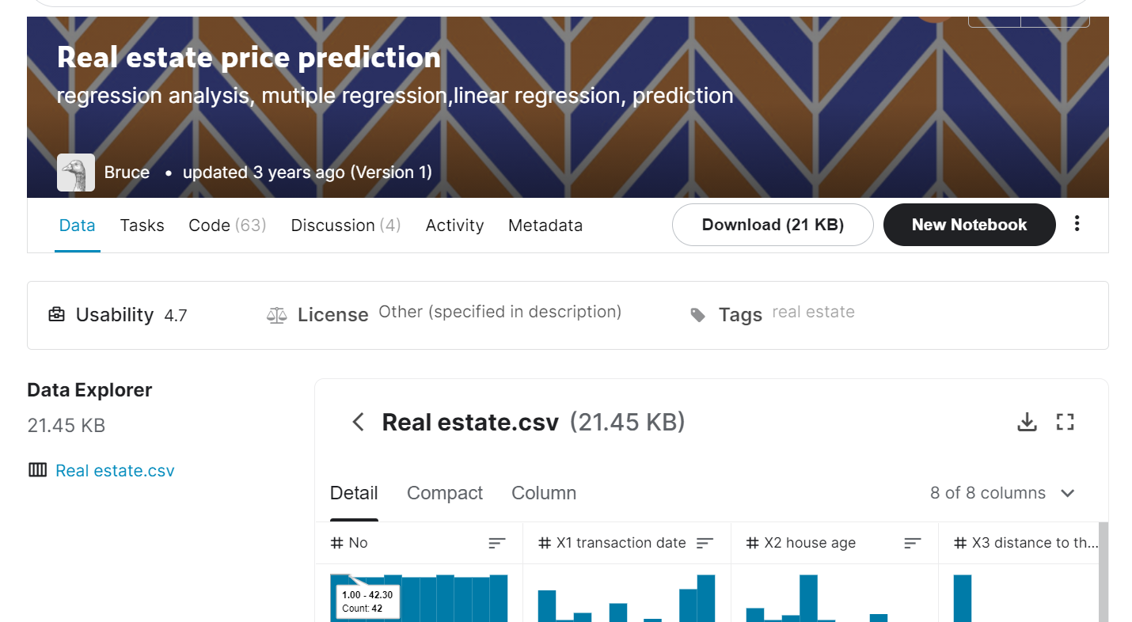

https://www.kaggle.com/quantbruce/real-estate-price-prediction

1. *Describe dataset.*

Dataset Real Estate Price Prediction digunakan untuk memprediksi harga real estate melalui modelling LinearRegression.

1. *Determine the tasks of dataset.*

Task : Memprediksi harga rumah berdasarkan faktor kedekatan ke stasiun MRT dan jumlah minimarket disekitarnya.

1. *What kinds of data provided by the dataset?*

Jenis data dalam dataset : structure berbentuk .csv

1. *Which analytical approach will be used?*

Predictive analytics

1. *What are the use of the result of analytical approach?*

Hasil approach predictive analytics digunakan untuk memprediksi harga.

1. *For whom the result be beneficial?*

Developer real estate, kontraktor.

1. *Can it be possible to improve the result with another approaches?*

Yes, it can be possible by prescriptive analytics.

1. *Choose one notebook and analyse it in the framework of data science methodology.*

https://www.kaggle.com/aishwaryajmp/realestateprice-prediction-linear-regression/notebook

Business Understanding & Analytic Approach :

Checking correlations, HeatMap Correlation

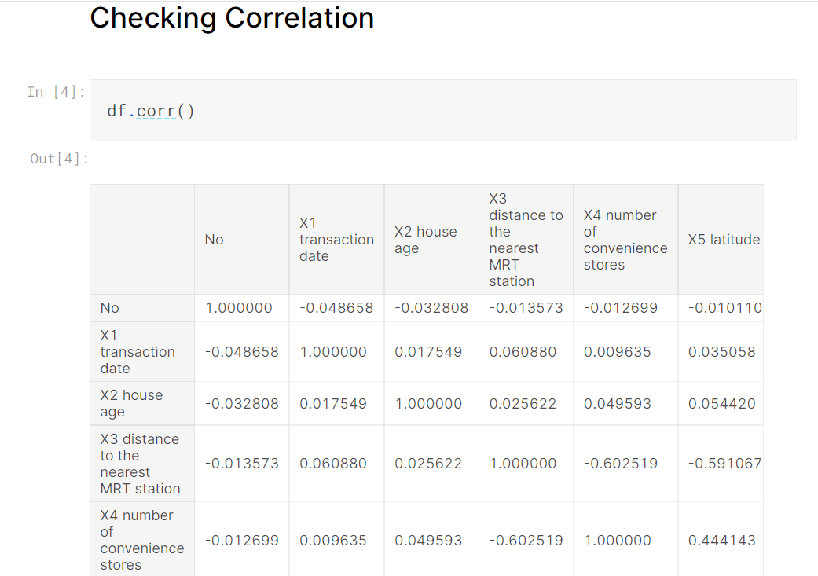

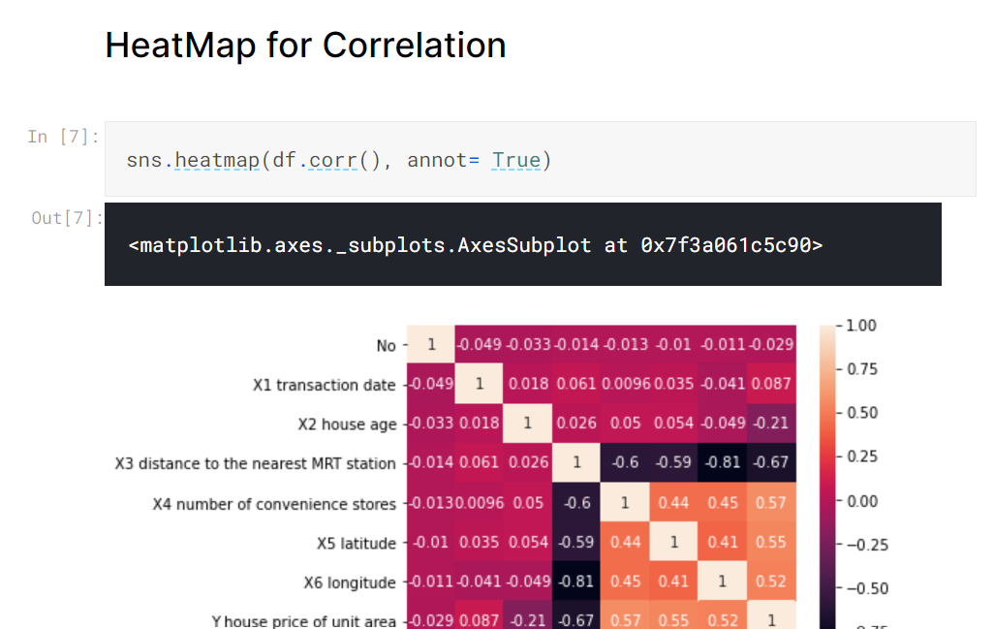

Data Preparation (Data Requirements, Data Collection, Data Understanding, Data Preparation) :

Splitting Dependent and Independent Features

Splitting Data Training and Data Testing

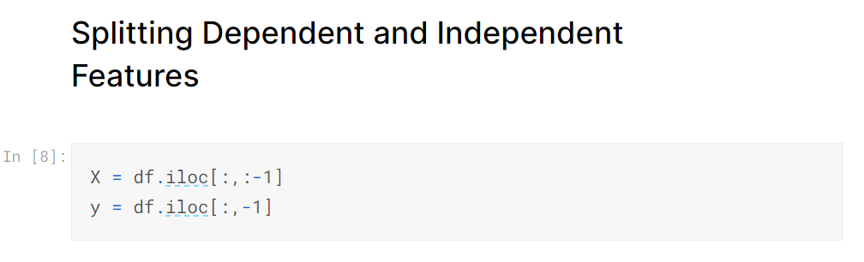

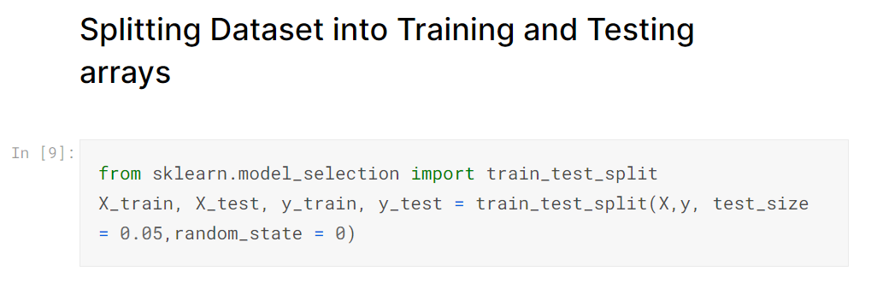

Modelling :

Training Model menggunakan LinearRegression

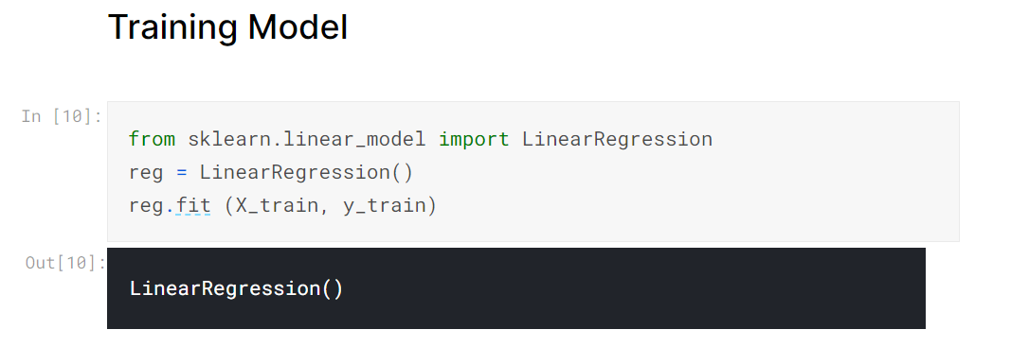

Evaluation :

